

Semester One Examination, 2021
Question/Answer booklet

MATHEMATICS
SPECIALIST
UNIT 1

SOLUTIONS
Section Two:
Calculator-assumed
WA student number: In figures

In words

Your name
Number of additional
answer booklets used
(if applicable):

Time allowed for this section
Reading time before commencing work: ten minutes
Working time: one hundred minutes

Materials required/recommended for this section
To be provided by the supervisor
This Question/Answer booklet
Formula sheet (retained from Section One)

To be provided by the candidate
Standard items: pens (blue/black preferred), pencils (including coloured), sharpener,
correction fluid/tape, eraser, ruler, highlighters

Special items: drawing instruments, templates, notes on two unfolded sheets of A4 paper, and up to three calculators, which can include scientific, graphic and Computer Algebra System (CAS) calculators, are permitted in this ATAR course examination

Important note to candidates
No other items may be taken into the examination room. It is your responsibility to ensure that you do not have any unauthorised material. If you have any unauthorised material with you, hand it to the supervisor before reading any further.

Structure of this paper

Section | Number of  questions  available | Number of  questions to  be answered | Working  time  (minutes) | Marks  available | Percentage  of  examination
Section One:  Calculator-free | 8 | 8 | 50 | 50 | 35
Section Two:  Calculator-assumed | 13 | 13 | 100 | 92 | 65
 |  |  |  | Total | 100

Instructions to candidates

1. The rules for the conduct of examinations are detailed in the school handbook. Sitting this examination implies that you agree to abide by these rules.

2. Write your answers in this Question/Answer booklet preferably using a blue/black pen.
Do not use erasable or gel pens.

3. You must be careful to confine your answers to the specific question asked and to follow any instructions that are specific to a particular question.

4. Show all your working clearly. Your working should be in sufficient detail to allow your answers to be checked readily and for marks to be awarded for reasoning. Incorrect answers given without supporting reasoning cannot be allocated any marks. For any question or part question worth more than two marks, valid working or justification is required to receive full marks. If you repeat any question, ensure that you cancel the answer you do not wish to have marked.

5. It is recommended that you do not use pencil, except in diagrams.

6. Supplementary pages for planning/continuing your answers to questions are provided at the end of this Question/Answer booklet. If you use these pages to continue an answer, indicate at the original answer where the answer is continued, i.e. give the page number.

7. The Formula sheet is not to be handed in with your Question/Answer booklet.
Section Two: Calculator-assumed 65% (92 Marks)
This section has thirteen questions. Answer all questions. Write your answers in the spaces provided.

Working time: 100 minutes.

Question 9 (5 marks)
Determine $p$, the vector projection of

(a) a force of $210$ N on a bearing $022°$ onto a force of $300$ N on a bearing of $350°$. (3 marks)
Solution
$$\left|p\right|=210\cos{32°}=178 \text{N}$$

Hence $p$ is a force of $178$ N on a bearing of $350°$.

Specific behaviours
calculates angle between vectors
ü calculates magnitude
ü states direction and magnitude

(b) $v$ on $w$ where $v=\left(-16, 63\right)$ and $w=\left(24, -7\right)$. (2 marks)
Solution
$$p=\frac{v∙w}{w∙w}w \\ =\frac{-825}{625}w \\ =(-31.68, 9.24)$$

Specific behaviours
indicates method (possibly CAS)
ü calculates vector

Question 10 (5 marks)
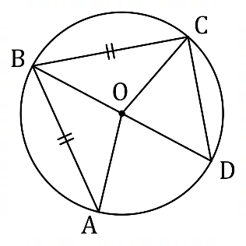
Points $A, B, C$ and $D$ lie on the circle with
centre $O$ as shown in the diagram,
where $∠A=40°$, $AB=BC$ and
$BD$ is a diameter.

(a) Determine the size of $∠AOD$. (2 marks)
Solution
Isosceles triangle: $∠ABO=∠A=40°$
Angle on same arc: $∠AOD=2×40°=80°$

Specific behaviours
indicates correct reasoning
ü calculates angle

(b) Prove that $ΔOAD≡ΔODC$. (3 marks)
Solution
Angle in semicircle: $∠BAD=∠BCD=90°$

Hence $ΔBAD≡ΔBCD \text{(RHS)}$ and so $CD=AD$ (corresponding sides)

Hence $ΔOAD≡ΔODC \text{(SSS)}$

(No need to show congruency of radii, diameter, etc)
Specific behaviours
establishes a pair of congruent triangles
ü establishes congruent sides or angles
ü states appropriate reason for congruency

Question 11 (6 marks)
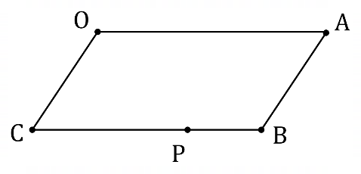
Parallelogram $OABC$ is shown where point $P$
lies on side $BC$ such that $BP:PC=1:3$.
Point $Q$, not shown, lies on diagonal $AC$
such that $AQ:QC=2:1$.

Let $\vec{OA}=a$ and $\vec{OC}=c$.

Express the following in terms of $a$ and $c$.

(a) $\vec{OB}$. (1 mark)
Solution
$$\vec{OB}=a+c$$

Specific behaviours
correct expression

(b) $\vec{AQ}$. (2 marks)
Solution
$$\vec{AQ}=\frac{2}{3}\vec{AC}=\frac{2}{3}(c-a)$$

Specific behaviours
uses ratio correctly
ü correct expression

(c) $\vec{QP}$. (3 marks)
Solution
$$\vec{QP}=\vec{QC}+\vec{CP} \\ =\frac{1}{3}\left(c-a\right)+\frac{3}{4}a \\ =\frac{1}{3}c+\left(\frac{3}{4}-\frac{1}{3}\right)a \\ =\frac{1}{3}c+\frac{5}{12}a$$

Specific behaviours
expresses as sum of vectors
ü expresses individual vectors correctly
ü simplifies, using correct vector notation throughout

Question 12 (8 marks)
(a) State whether each of the following statements are true or false, supporting each answer with an example or counterexample.

(i) A quadrilateral with four congruent sides is a square. (2 marks)
Solution
False. Counterexample: rhombus.

Specific behaviours
states false
ü draws or names counterexample

(ii) The size of one interior angle of a regular polygon with at least five sides is always obtuse. (2 marks)
Solution
True. Interior angle of a regular hexagon is $120°$, an obtuse angle.

Specific behaviours
states true
ü example with obtuse angle calculated

(b) Consider the statement $∠A≥90°⇒∠B<90°$ that refers to angles in triangle $ABC$.

(i) Write the converse of the statement in simplest form. (1 mark)
Solution
$$∠B<90°⇒∠A≥90°$$

Specific behaviours
correct converse

(ii) Write the contrapositive of the statement in simplest form. (1 mark)
Solution
$$∠B≥90°⇒∠A<90°$$

Specific behaviours
contrapositive that doesn't use 'not'

(iii) Briefly discuss the truth of the original statement, the converse statement, and the contrapositive statement. (2 marks)
Solution
The original statement is true and so is the contrapositive, by definition. However, the converse is false - when the triangle is acute, for example.

Specific behaviours
states original and contrapositive true
ü states converse false, with justification

Question 13 (7 marks)
(a) Points $P, Q$ and $R$ lie on a circle of radius $3$ cm, so that $PR$ is a diameter and $PQ=4$ cm. Determine the exact area of triangle $PQR$. (3 marks)
Solution
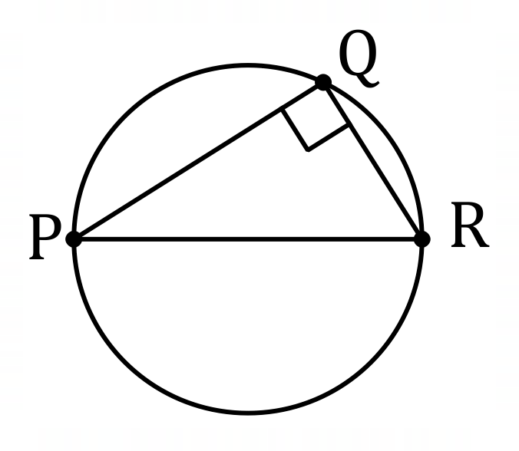
$$PR=6, PQ=4⇒BC=\sqrt{6^{2}-4^{2}}=\sqrt{20}$$
$$\text{Area}=\frac{1}{2}\left(4\right)2\sqrt{5}=4\sqrt{5} {\text{cm}}^{2}$$

Specific behaviours
indicates $PQR$ is right triangle
ü calculates missing side
ü calculates area

(b) A secant meets a circle at points $P$ and $Q$, where $PQ=8$ cm. A tangent to the same circle at point $T$ intersects the secant at point $R$, where $TR=12$ cm. Given that $QR<PR$, determine the exact distance $PR$ and the exact distance $QR$. (4 marks)
Solution
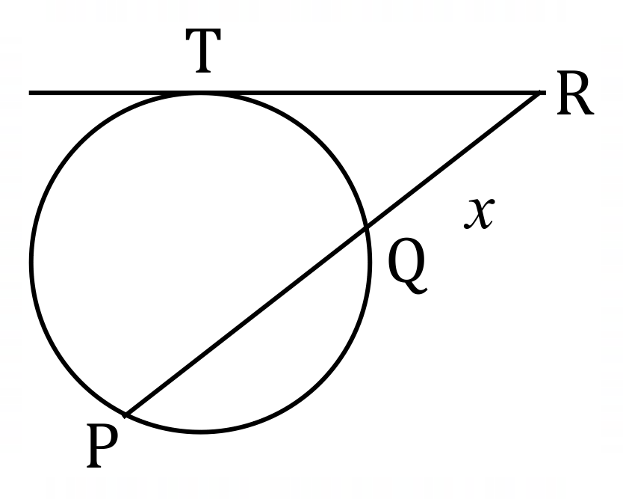
Using secant-tangent theorem:
$${12}^{2}=x\left(x+8\right) \\ QR=x=4\sqrt{10}-4 \text{cm} \\ PR=QR+8=4\sqrt{10}+4 \text{cm}$$

Specific behaviours
sketch diagram
ü formulates equation
ü solves equation for positive distance
ü calculates second distance

Question 14 (8 marks)
A small body is acted on by force $F_{1}$ of $85$ N on a bearing of $260°$ and by force $F_{2}$ of $45$ N on a bearing of $025°$.

(a) Sketch a diagram to show $F_{1}+F_{2}$ and their resultant $R$. (2 marks)
Solution
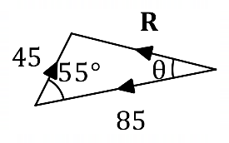
Specific behaviours
nose-to-tails vectors
ü labels and angle

(b) Determine the magnitude and bearing of $R$. (4 marks)
Solution
$$r^{2}={45}^{2}+{85}^{2}-2\left(45\right)\left(85\right)\cos{55°}⇒r=69.7 \text{N}$$

$$\frac{\sin{θ}}{45}=\frac{\sin{55°}}{69.7}⇒θ=31.9°$$
$$260°+32°=292°$$

Magnitude of $R$ is $69.7$ N and bearing is $292°$.

Specific behaviours
expression using cosine rule with magnitude
ü calculates magnitude
ü expression using sine rule with angle
ü calculates bearing

(c) Express $R$ in component form $ai+bj$. (2 marks)
Solution
Angle of $R$ from $x$-axis is $158.1°$.

$$R=69.7\left(\cos\left(158.1°\right)i+\sin\left(158.1°\right)j\right) \\ =-64.7i+26.0j$$

Specific behaviours
indicates method (possibly CAS)
ü calculates components

Question 15 (8 marks)
Consider the set of integers between $1000$ and $7000$ inclusive.

(a) Show that there are $546$ integers in this set that are a multiple of $11$. (2 marks)
Solution
Number of multiples from $1$ to upper bound: $n=\left\lfloor 7000÷11\right\rfloor =636$Number of multiples from $1$ to lower bound: $n=\left\lfloor 1000÷11\right\rfloor =90$
Hence $636-90=546$ multiples in interval.

Specific behaviours
calculates multiples from $1$ to lower, upper bounds
ü calculates difference

(b) Determine the number of integers in this set that are

(i) a multiple of $11$ and a multiple of $24$. (3 marks)
Solution
$$LCM\left(11, 24\right)=264$$

$$n=\left\lfloor 7000÷264\right\rfloor -\left\lfloor 1000÷264\right\rfloor =26-3=23$$

Specific behaviours
states LCM
calculates multiples from $1$ to lower, upper bounds
ü calculates difference

(ii) not a multiple of $11$ and not a multiple of $24$. (3 marks)
Solution
Multiples of $24$: $n=\left\lfloor 7000÷24\right\rfloor -\left\lfloor 1000÷24\right\rfloor =291-41=250$

Multiples of $11$ or $24$: $n=546+250-23=773$

Number of integers: $\left(7000-1000+1\right)-773=6001-773=5228$

Specific behaviours
multiples of $24$
ü multiples of $11$ or $24$
ü correct number of integers

Question 16 (7 marks)
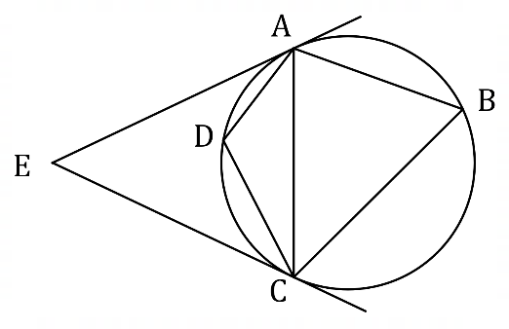
(a) The diagram shows points $A, B, C$ and $D$ on
the circumference of a circle. Tangents to
the circle from $A$ and $C$ meet at point $E$.
Given that $∠E=48°$, determine
the size of $∠B$ and the size of $∠D$.

Solution
Isosceles triangle: $∠EAC=\frac{1}{2}\left(180°-48°\right)=66°$

Alternate segment: $∠B=66°$

Cyclic quadrilateral: $∠D=180°-66°=114°$

Specific behaviours
shows use of at least two relevant circle theorems
ü first angle
ü second angle

(3 marks)

(b) In the circle shown below $∠A=33°$, $∠C=28°$ and $θ=119°$.
Prove by contradiction that $X$ is not the centre of the circle. (4 marks)

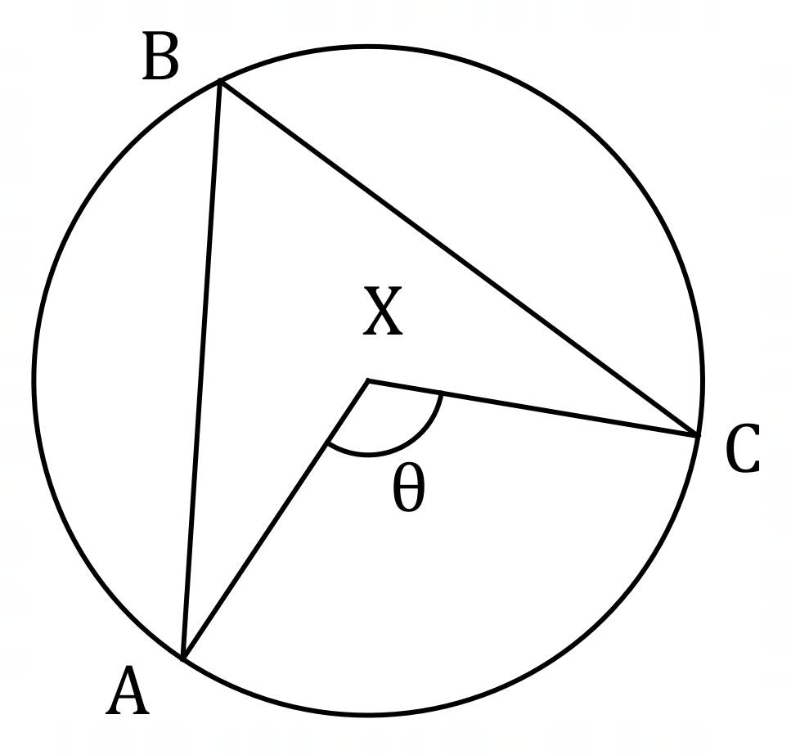
Solution
Assume that $X$ is the centre of the circle.

Then $∠ABX=∠A=33°$ (isosceles triangle)
and $∠CBX=∠C=28°$(isosceles triangle).

Hence $∠B=33°+28°=61°$and $θ=2×61°=122°$ (angles at centre - circumference).

But this contradicts the initial information that $θ=119°$ and so the initial assumption must be wrong. Hence $X$ is not the centre of the circle.

Specific behaviours
clearly states assumption that $X$ is centre of circle
ü uses isosceles triangles to calculate $∠B$
ü uses angle at centre - circumference theorem
ü notes contradiction and draws conclusion

Question 17 (8 marks)
Each letter in the word ACRIMONIOUS is printed individually on a card. When cards are arranged next to each other in a line, determine the number of different permutations

(a) of all the cards. (2 marks)
Solution
Note: There are two I's and two O's.

$$n=\frac{11!}{2!2!}=9 979 200$$

Specific behaviours
expression that allows for repeated letters
ü calculates number

(b) of all the cards where all the consonants are adjacent. (2 marks)
Solution
Note: There are five consonants that form a group to be arranged with the remaining six letters.

$$n=\frac{7!5!}{2!2!}=151 200$$

Specific behaviours
explains or clearly indicates grouping of consonants
ü calculates number

(c) using any $4$ of the cards. (4 marks)
Solution
Consider cases by selecting and then arranging:

1. All letters different
$$n_{1}=\left(\begin{matrix}9 \\ 4\end{matrix}\right)×4!=126×24=3024$$
2. One pair (II or OO) and two different:
$$n_{2}=2×\left(\begin{matrix}8 \\ 2\end{matrix}\right)×\frac{4!}{2!}=56×12=672$$
3. Two pairs (II and OO):
$$n_{3}=1×\frac{4!}{2!2!}=1×6=6$$

Number of permutations: $3024+672+6=3702$

Specific behaviours
identifies mutually exclusive cases
ü counts one case correctly
ü counts second case correctly
ü counts all cases correctly and calculates total

Question 18 (8 marks)
Small bodies $P$ and $Q$ are moving with constant velocities $(2, -2)$ m/s and $(1, 0)$ m/s respectively.

$P$ has initial position vector $(5, 7)$ m and $Q$ has initial position vector $(-3, 13)$ m.

(a) Determine the distance between the bodies after two seconds. (3 marks)
Solution
Positions after two seconds:
$$r_{P}=\left(\begin{matrix}5 \\ 7\end{matrix}\right)+2\left(\begin{matrix}2 \\ -2\end{matrix}\right)=\left(\begin{matrix}9 \\ 3\end{matrix}\right) \\ r_{Q}=\left(\begin{matrix}-3 \\ 13\end{matrix}\right)+2\left(\begin{matrix}1 \\ 0\end{matrix}\right)=\left(\begin{matrix}-1 \\ 13\end{matrix}\right) \\ \vec{PQ}=\left(\begin{matrix}-1 \\ 13\end{matrix}\right)-\left(\begin{matrix}9 \\ 3\end{matrix}\right)=\left(\begin{matrix}-10 \\ 10\end{matrix}\right) \\ \left|\vec{PQ}\right|=10\sqrt{2}≈14.14 \text{m}$$

Specific behaviours
positions
ü vector $\vec{PQ}$
ü distance

(b) Show that the distance between the bodies after $t$ seconds is given by $\sqrt{5t^{2}+40t+100}$.
(3 marks)
Solution
$$r_{PQ}=\left(\begin{matrix}-3 \\ 13\end{matrix}\right)+t\left(\begin{matrix}1 \\ 0\end{matrix}\right)-\left(\begin{matrix}5 \\ 7\end{matrix}\right)-t\left(\begin{matrix}2 \\ -2\end{matrix}\right) \\ =\left(\begin{matrix}-t-8 \\ 2t+6\end{matrix}\right)$$

$$\left|r_{PQ}\right|=\sqrt{{\left(-t-8\right)}^{2}+{\left(2t+6\right)}^{2}} \\ =\sqrt{5t^{2}+40t+100}$$

Specific behaviours
ü vector $\vec{PQ}$ at time $t$
ü simplifies vector
ü expression for magnitude and simplifies

(c) Prove that the bodies do not meet. (2 marks)
Solution
Require $5t^{2}+40t+100=0$:

$$Δ=b^{2}-4ac={40}^{2}-4\left(5\right)\left(100\right)=-400$$

Since the discriminant is negative, the distance can never be zero and hence the bodies never meet.

Specific behaviours
states condition for bodies to meet
ü justifies that condition never met

Question 19 (7 marks)
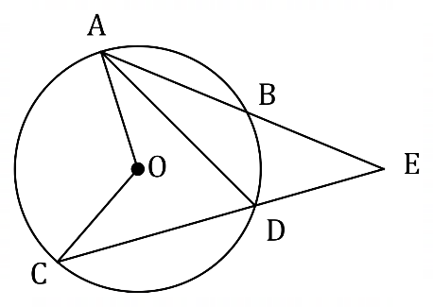
In the diagram shown, secants $AB$ and $CD$
intersect at $E$, a point outside the circle
with centre $O$.

(a) Determine the size of $∠ADC$ and $∠AOC$ when $∠E=28°$ and $∠EAD=22°$. (2 marks)
Solution
$$∠ADC=28°+22°=50°$$
$$∠AOC=2×50°=100°$$

Specific behaviours
first angle
ü second angle

(b) Prove that when secants $AB$ and $CD$ intersect at $E$, a point outside the circle with centre $O$, then $∠E=\frac{1}{2}\left(∠AOC-∠BOD\right)$. (4 marks)
Solution
Exterior angle of triangle: $∠ADC=∠E+∠BAD$

Inscribed angles: $∠ADC=\frac{1}{2}∠AOC$
Inscribed angles: $∠BAD=\frac{1}{2}∠BOD$

Substituting: $∠E=\frac{1}{2}∠AOC-\frac{1}{2}∠BOD$

Factoring: $∠E=\frac{1}{2}\left(∠AOC-∠BOD\right)$

Specific behaviours
relation using exterior angles
ü uses inscribed angles twice
ü substitutes and factors
ü notes reasoning throughout

(c) Determine the size of $∠E$ when $∠BOD=30°$ and $∠AOC=80°$. (1 mark)
Solution
$$∠E=\frac{1}{2}\left(80°-30°\right)=25°$$

Specific behaviours
correct angle

Question 20 (7 marks)
(a) A manufacturer makes the same plastic toy figure in $12$ different colours and sells them in packs of three. The toys inside each pack are randomly chosen from the production line in such a way that all are of a different colour.
Determine the least number of packs that a retailer should buy from the manufacturer to be certain of obtaining at least four packs containing the same colour combination of toys.
(3 marks)
Solution
There are $\left(\begin{matrix}12 \\ 3\end{matrix}\right)=220$ different packs.

Using the pigeonhole principle with the number of different packs as pigeonholes ($220$) and the number bought by the retailer as pigeons ($n$):

$$\left\lceil n÷220\right\rceil =4⇒n=220×3+1=661$$

The retailer must buy at least $661$ packs.

Specific behaviours
calculates different number of packs
ü applies pigeonhole principle
ü correct least number

(b) A set of cards is numbered with all the integers from $1$ to $15$ inclusive. The cards are shuffled, placed face down and then the cards turned over one by one.
Determine how many cards must be turned over to be certain that at least one of the numbers on a face up card will be three times the number on another face up card.
(4 marks)
Solution
Partition integers (pigeons) into pigeonholes, with any pair meeting given condition in same pigeonhole:

$$\left\{1, 3\right\} \left\{2, 6\right\} \left\{4, 12\right\} \left\{5, 15\right\} \left\{7\right\} \left\{8\right\} \{9\} \left\{10\right\} \left\{11\right\} \left\{13\right\} \left\{14\right\}$$

There are $11$ pigeonholes and so $11+1$ pigeons are required.

$12$ cards must be turned over to be certain.

Specific behaviours
treats integers as pigeons
ü identifies pigeonholes
ü indicates use of pigeonhole principle
ü correct number

Question 21 (8 marks)
Harbour $Y$ lies on a bearing of $065°$ from harbour $X$ and the straight line distance between the harbours is $43$ km. Between the harbours, a steady current is moving in a south easterly direction at a speed of $1.5$ metres per second.

A boat with a cruising speed of $5.5$ metres per second is to travel from harbour $X$ to harbour $Y$ in the least possible time.

(a) Sketch a diagram, roughly to scale, to show the resultant of the sum of the displacement vectors of the boat and the current. (2 marks)
Solution
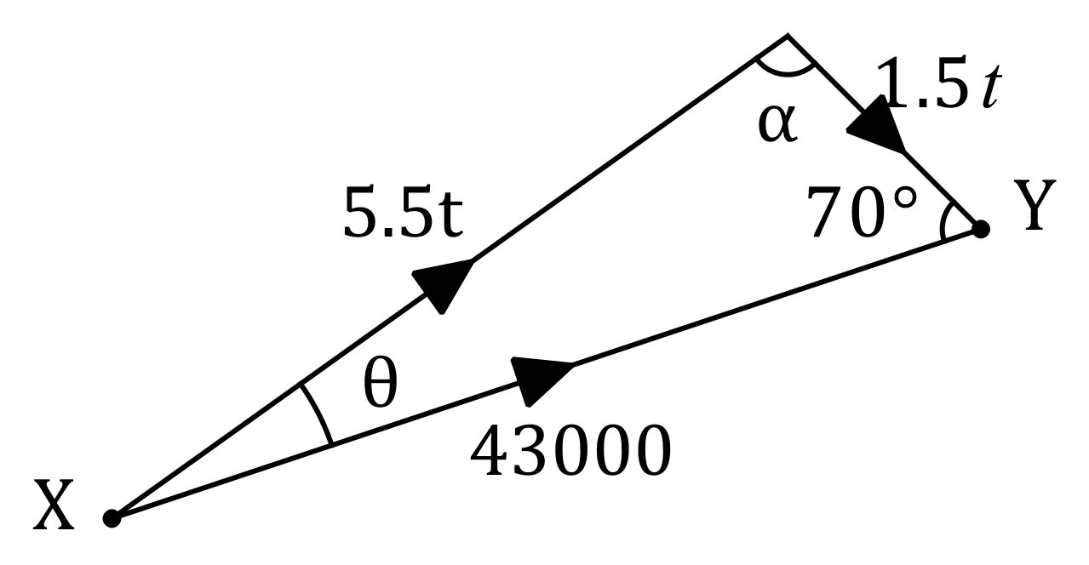
Specific behaviours
shows vector triangle, roughly to scale
ü labels $X$ and $Y$, sides, indicates angle

(b) Determine the bearing it should steer, to the nearest degree, and the time its journey takes, to the nearest minute. (6 marks)
Solution
$$\frac{\sin{θ}}{1.5t}=\frac{\sin{70°}}{5.5t}⇒θ=14.85°$$

$$α=180°-70°-14.85°=95.15°$$

$$\frac{5.5t}{\sin{70°}}=\frac{43 000}{\sin{95.15°}}⇒t=7376 \text{s}$$

$$7376÷60=122.9 \text{min}$$

$$065°-14.85°≈050°$$

Boat should steer on bearing of $050°$ and will reach $Y$ after $2$ hours and $3$ minutes.

Specific behaviours
equation involving $θ$
ü solves for $θ$
ü equation involving $t$
ü solves for $t$
ü calculates and states bearing
ü states time, to nearest minute

Supplementary page

Question number: _________

Supplementary page

Question number: _________

Supplementary page

Question number: _________

Supplementary page

Question number: _________

© 2021 WA Exam Papers. Kennedy Baptist College has a non-exclusive licence to copy and communicate this document for non-commercial, educational use within the school. No other copying, communication or use is permitted without the express written permission of WA Exam Papers. SN245-171-4.

